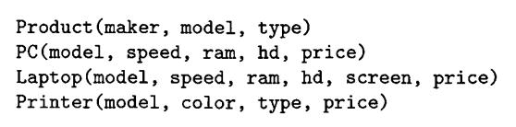
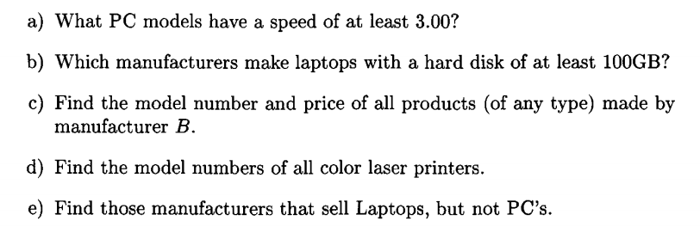
f) Find those hard- disk sizes that occur in two or more PC’s

a) π_{model}(σ_{speed >= 3.00} (PC))
b) π_{maker}(σ_{hd >= 100}(Laptop ⋈ Product))
c) π_{model,price} (σ_{maker=’B’}(Product ⋈ ( PC ∪ Laptop ∪ Printer )))
d) π_{model} (σ_{type=’laser’ ^ color =’color’} (Printer))
e) π_{maker} (Product - π_{maker}(σ_{type=’pc’} (Product)) ⋈ Laptop)

